BUSINESS REQUIREMENT DOCUMENT

<<Communication Journey: Placement Call from CRM>>

<<Dhawal Sah>>

<<Aravind Ravi Sankar>>

**VERSION: 1.0**

DATE <<2022-05-24 >>

**TABLE OF CONTENTS**

**1.1 Problem Statement/ Requirement Background** **3**

**1.2 Current Solution/Process (if any)** **3**

**1.3 Related Documents** **3**

**1.4 Solution Scope** **3**

**1.5 Constraints** **3**

**1.6 Business Goals and Objectives** **3**

**1.7 Priority** **3**

**1.8 Target User/ User Community** **3**

**1.9 Impact Analysis** **4**

**1.10 Additional Information** **4**

**1.11 Stakeholder consultation** **4**

**1.12 Approvers** **4**

### 

### 1.1 Problem Statement/ Requirement Background

What are the current problem statements faced by the Business owner?

Currently, no notifications are being sent to an aspirant regarding the placement calls he has received from his/her POC. Also POCs and Career Coaches are not being notified regarding the status of the call made to an aspirant.

Provide a brief introduction to the project. This includes describing the business context of the project and the users.

Placement Call is a feature on CRM through which a placement POC can connect with an aspirant over call. Since the call gets connected only if both the parties answer the call, there are a lot of cases where the call does not get connected to the aspirant. Therefore, it is important to inform both the authorities regarding the status of the call

### 1.2 Current Solution/Process (if any)

Describe the current environment as it relates to the solution scope for this document. Does the client have an existing solution? What is it? What are some of its key challenges? What is being done manually?

Currently, Placement Calls is a feature used to place call to an aspirant through CRM. Some of it’s features are:

* ability to place calls to an aspirant
* displays the status of the call i.e. “Answered” or “Not Answered”
* displays the aspirant to whom call was placed and the placement POC who placed the call
* displays the time call was placed and the duration of the call

Some of the key challenges include:

* aspirant is unaware of the placement call made to him, since the call is placed over a random number
* aspirant does not receive any notification of the details conveyed to him during the call
* placement POC does not receive any notification regarding the status of the call
* POC sometimes forgets to make a follow-up call
* POC has to make a follow-up mail every time an aspirant fails to respond more than 2 calls
* if aspirant is not responding, POC has to manually contact a Career Coach

Currently, the following are being done manually

* POC has to manually connect to a Career Coach, in case an aspirant is not responding
* POC has to manually send mails to an aspirant if he/she is not responding
* POC has to send details over mail to an aspirant

If the current solution has financial impacts, provide a high-level description.

Currently, there are 6 POCs incurring an average cost of 300 per sim which incurs to 1800 per month and as the aspirants increase the POC would increase and so do the cost.

### 1.3 Related Documents

Reference any business deliverables/documents associated with this requirements document.

### 1.4 Solution Scope

Define the scope of the solution that this document describes. Indicate any components no longer in scope (e.g., scope changes from that described in the Preliminary Scope document).

Business Needs are of an automated Communication Journey for the placement calls feature having the following components:

* automated mails to the aspirant informing him regarding the status of the placement calls
* automated mails to the aspirant notifying him of the details conveyed in the call
* automated mails to the POC notifying him/her of the status of the placed call to the aspirant
* reminder mail to the POC if he/she forgets to callback an aspirant
* automated mail to the Career Coach if an aspirant fails to answer 2 consecutive calls

Detailed Breakdown of these priorities: [Placement Calls - Feature and Priority List](https://docs.google.com/spreadsheets/d/11uH1H8gAmp2_EFDl-qFWKCVRC-BlzT4gVk4LFxKRGWU/edit#gid=0)

### 1.5 Constraints

What are the business goals and objectives we are trying to achieve with this project

### 1.6 Business Goals and Objectives

What are the business goals and objectives we are trying to achieve with this project

Implementing a Communication Journey to the Placement Calls would increase the aspirant interaction with the process. It would relieve Placement POCs and Career Coaches of their tedious task of following up with an aspirant, thus increasing their bandwidth. I would also help in improving the user journey, this ultimately would lead to a better user experience, thus improving the feedback towards the whole system.

### 1.7 Priority

Use the following three categories to prioritize requirements (do not introduce and mix other prioritization methods such as the MoSCoW method):

* **High** to indicate a solution element that is critical to the client’s business function and operation;
* **Medium** to indicate a non-critical solution element that provides significant benefit to the client; and
* **Low** to indicate a non-critical solution element that provides a helpful or convenient feature that is beneficial to the client.

Detailed Breakdown of these priorities: [Placement Calls - Feature and Priority List](https://docs.google.com/spreadsheets/d/11uH1H8gAmp2_EFDl-qFWKCVRC-BlzT4gVk4LFxKRGWU/edit#gid=0)

### 1.8 Target User/ User Community

If applicable, identify all possible user groups for the solution.

For each user group, estimate the number of users and reference the functional areas each will need access to.

All the Aspirants currently involved in the Placement Pool.

All the Placement POCs and Career Coaches

### 1.9 Impact Analysis

How is this product/feature

Additional Features

### 1.10 Additional Information

Include any information related to the requirement (e.g., hyperlinks to related online content). Where appropriate:

* Reference the associated business process model within the *Business Process Definition* document; and
* Identify the owner (e.g., source) of the requirement.

Communication Journey should include the following:

* Email Content - [Link](https://docs.google.com/spreadsheets/d/11uH1H8gAmp2_EFDl-qFWKCVRC-BlzT4gVk4LFxKRGWU/edit#gid=0) (Doc links provided in the sheet)
* Flowthrough - [Link](https://docs.google.com/spreadsheets/d/11uH1H8gAmp2_EFDl-qFWKCVRC-BlzT4gVk4LFxKRGWU/edit#gid=0) (Flowchart Sheet)

**Additional Features**

There are some additional features which need to be added for the smooth functioning of communication Journey. Also these features are necessary for better tracking of activities of placement coordinators with the aspirants:

1. Instantly after the placement call is disconnected, the Track Update pop - up should appear and there should be no cancel option, it is necessary for a placement coordinator to add the track activity. This because, the content of track activity is sent to the aspirant in the communication journey
2. It is important that at least the answered calls should have Track Update to be submitted by the placement coordinator.
3. All Placement call emails should be sent and received through a Common Email ID to ensure everyone is in the loop including the Placement GLs and Head

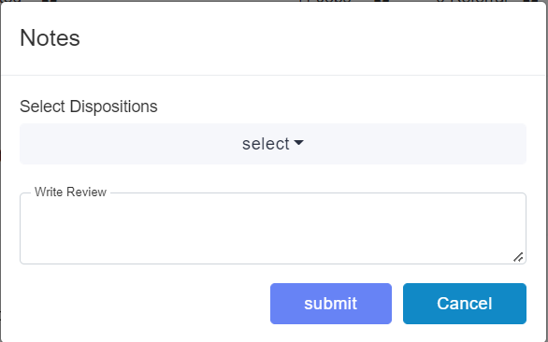 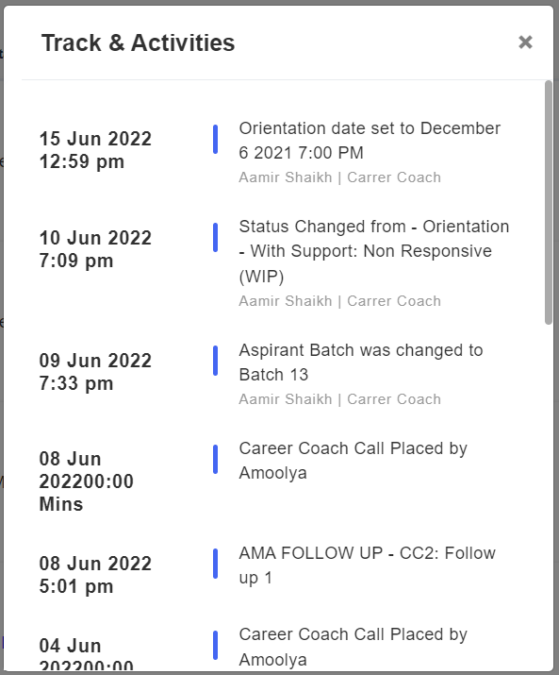

### 1.11 Stakeholder consultation

Identify the stakeholders for the solution and for the project, what their role(s) are, and whether they were consulted.

| **Stakeholder Name** | **Role** | **Consulted** |
| --- | --- | --- |
| Simran Merchant | Assisted in understanding the placement call feature and the adoption of those features on CRM | Yes |
| Siddarth Nautiyal | Conveyed all the CRM features and also assisted me in understanding the Communication Journey | Yes |
| Aravind Ravi Sankar | Reviewed all the Communication Journeys and all the use cases | Yes |
| Sachit Moosewala | Reviewed the Communication Journey and suggested some changes | Yes |

### 1.12 Approvers

The following individuals have approved the financial requirements on the date indicated.

| **Approver Name** | **Role** | **Approved** |
| --- | --- | --- |
|  |  | << Yes / No >> |
|  |  | << Yes / No >> |
|  |  | << Yes / No >> |